**A Comprehensive Guide to Filters in Power BI: Unlocking the Power of Data**

In the sector of statistics visualization, the capability to filter and refine statistics is essential for uncovering insights and making informed choices. Power BI, an effective commercial enterprise analytics tool from Microsoft, offers quite a few filtering alternatives to help customers recognize the records that matter most. Whether you’re crafting a record, reading tendencies, or imparting information to stakeholders, the extraordinary forms of filters in Power BI can drastically beautify the effectiveness of your information-driven storytelling.

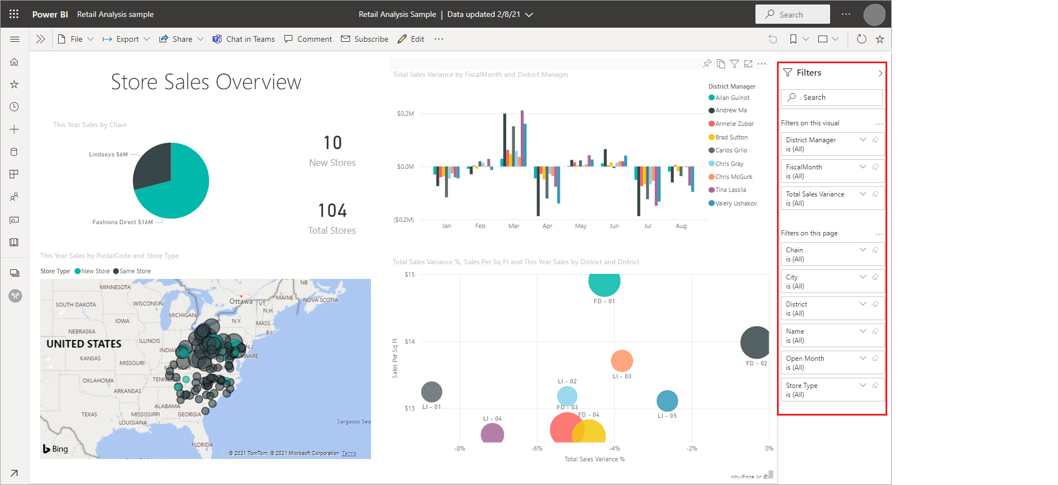

*(Source:Microsoft)*

**Visual-Level Filters: Fine-Tuning Individual Visuals**

[Visual-degree filters](https://learn.microsoft.com/en-us/power-bi/create-reports/power-bi-report-filter-types) are the most granular filtering choice in Power BI, applying specifically to an unmarried visual inside your document. These filters permit you to control what statistics are proven in one visual without affecting others. For instance, when you have a bar chart that shows income data, you can use a visible-stage clear out to restrict the chart to only display sales from the cutting-edge 12 months. This sort of clear out is mainly useful while you need to highlight particular statistics points or developments in a selected visual, making sure that your target market’s interest is attracted to the most relevant information.

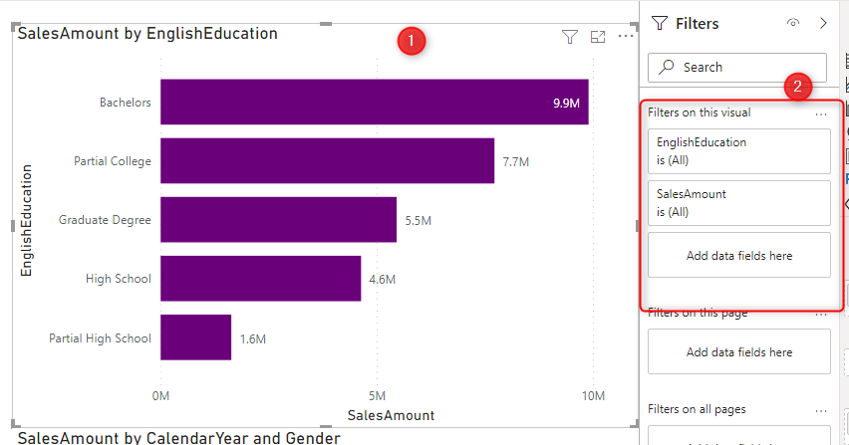

*(Source*[*:Radacad*](https://i0.wp.com/radacad.com/wp-content/uploads/2021/06/2021-06-24_08h10_47.png?ssl=1)*)*

**Page-Level Filters: Consistency Across a Page**

[Page-level filtering](https://www.geeksforgeeks.org/power-bi-page-level-filters/) enlarges the filtering radius and it encloses all images from the selected file page. When you apply a web-page filter to the visible on that page, it makes it easier for you to be consistent and recognizable among the couple of visuals. In the case, for instance, when your report page contains income facts of one region, you can apply the web page filter to show the statistics for only one region. This method enables the alignment of all visuals on the web page which in turn provides a clear picture of the data concerning the particular area.

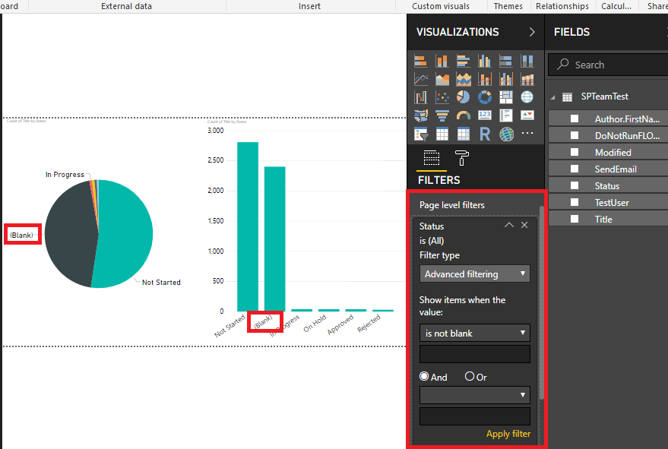

*(Source:*[*Cornor*](https://www.c-sharpcorner.com/blogs/power-bi-page-level-and-report-level-filters)*)*

**Report-Level Filters**

Uniformity Across the Entire ReportThe introduction of more filtering options [report-degree filters](https://www.geeksforgeeks.org/power-bi-report-level-filters/) allows observing the entire document's pages and visuals. Such a filter is most convenient when you want your target audience to see your statistics in a uniform manner as they go through all the pages of your document. For instance, you may find that if you are writing a document that is a branch-specific type of document, you can use a document-stage filter to best represent the data that is tied to that department. Thus, by doing this, you are certain that your audience has the information that is only relevant to the subject you are discussing, whether they look at the rest of the data or not.



*(Source:Microsoft)*

.

**Drillthrough Filters**

Diving Deeper into Details [Drillthrough filters](https://www.geeksforgeeks.org/power-bi-drill-through-filters/) are an interactive feature that allows users to navigate from a summary view to a more detailed view by right-clicking on a data point. This filter creates a dedicated, unique page that contains the data that is deeper and more complete than ever on a certain product, for example, or a customer. Drillthrough filters are precious for exploring facts at a granular level without overwhelming the main record pages with an excessive amount of detail.

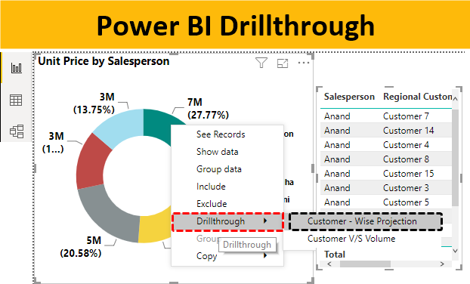

(Source:educba)

.

**Cross-Visual Filters: Enhancing Interactivity**

One of Power BI’s maximum powerful features is the capability to create interactive reports. Cross-visual filters allow this interactivity via robotically applying filters between associated visuals. For instance, clicking on a bar in a chart can filter out other charts at the page to expose related facts. This dynamic interaction facilitates users to discover the statistics in a more intuitive and tasty way.

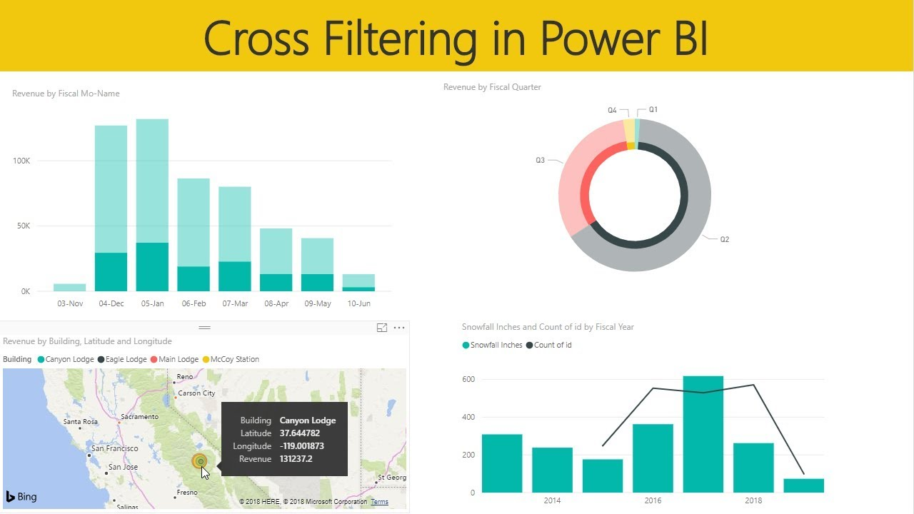

*(Source:Youtube)*

**Slicers: User-Friendly Filtering**

[Slicers](https://www.geeksforgeeks.org/power-bi-slicer/) are a consumer-pleasant way to use filters immediately on the document canvas. These visible controls, which may be in the shape of dropdowns, lists, or sliders, allow users to without difficulty clear out records with the aid of selecting particular values. Slicers are especially beneficial for making reviews more interactive, giving quit-users the ability to customize their view of the information.

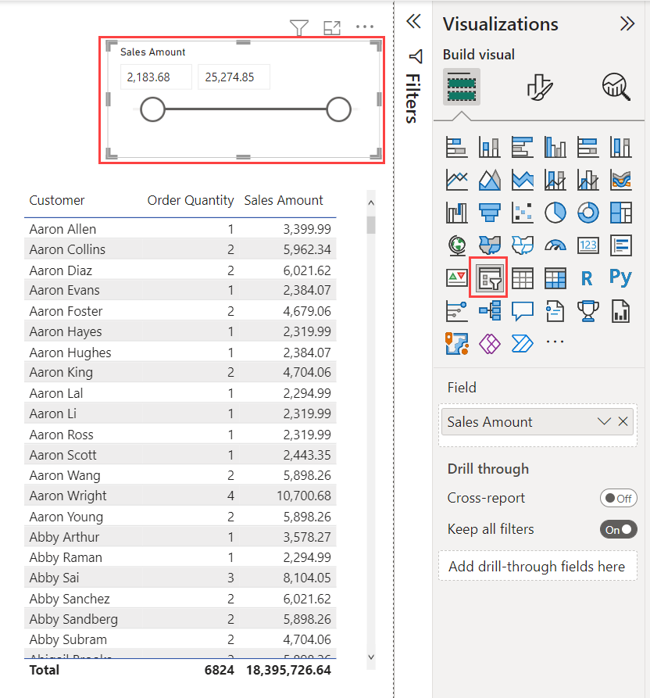

*(Source:Microsoft)*

**Advanced Filters: Precision and Complexity**

Advanced filters in Power BI are designed for users who need to go beyond primary filtering and apply greater complicated situations to their records. These filters will let you install a couple of criteria using logical operators inclusive of "AND" and "OR," supplying you with particular control over the facts that look at your visuals.

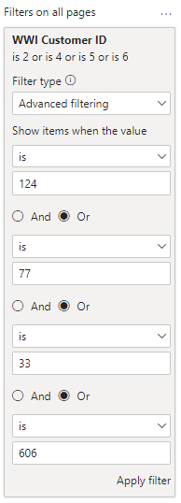

*(Source:Microsoft)*

**Conclusion: Harnessing the Full Potential of Power BI Filters**

Power BI’s filtering competencies are important equipment for turning raw data into significant insights. By understanding and correctly the usage of visible-degree, web page-degree, record-level, drillthrough, move-visual, slicers, and superior filters, you may create reports that are not simplest informative however additionally engaging and actionable. Whether you’re a beginner or an experienced Power BI user, studying these filters will help you free up the total ability of your records, permitting you to make more informed, statistics-pushed choices.